

INFORMATIC INSTITUTE OF TECHNOLOGY
UNIVERSITY OF WESTMINSTER
DATABASE SYSTEMS
5COSC020C.1
Module Leader :Mr. Sivaraman Ragu
Part A & B

Name: Muhammed Saad Mazhar
Uow Number: W2053223
IIT Number: 20221804
Tutorial Group: Group 17

TABLE OF CONTENTS

01. CRITICAL EVALUATION & REFLECTIVE COMMENTARY 2
1.1. Critical Evaluation 2
1.2. Reflective Commentary 3
02. ENTITIES 4
03. SPECIALISATIONS 5
04. RELATIONSHIPS & MULTIPLICITIES 7
05. ATTRIBUTES & PRIMARY KEYS 12
06. CONCEPTUAL EERD QUALITY & NOTATIONS 16
BUSINESS QUESTIONS 17

B. LOGICAL ENTITY RELATIONSHIP DIAGRAM (ERD) 18

CRITICAL EVALUATION & REFLECTIVE COMMENTARY

1.1. Critical Evaluation
- Inconsistent and Ambiguous Naming Conventions
While entity and attribute names are somewhat straightforward, there is a lack of uniformity and precision. Terms like Block Booking could be refined to Recurring Booking for clarity and consistency, while attribute names such as Booking Date could be made more specific, for example, Booking Start Date. This lack of precision can lead to misinterpretation of the schema’s intent.
- Crowded and Disorganized Layout
The diagram is cluttered, making it difficult to read and interpret. The tight spacing and inconsistent alignment obscure the relationships and hinder comprehension. Greater spacing and consistent alignment are essential to improve readability and simplify the tracing of entity connections.
- Vague Generic Attributes
Generic attributes like Status lack definition, leaving their purpose open to interpretation. While some attributes are relevant, others require further clarification. For example, the concept of a Session should include additional details such as Duration and Location to provide a complete representation.
- Unclear Cardinality Constraints
Cardinality constraints, though specified, lack clarity. The absence of directional labels makes it challenging to understand the nature of relationships between entities. For instance, the relationship between Booking and Player is poorly defined, leading to ambiguity about their interaction.

1.2. Reflective Commentary
- To enhance clarity and consistency in the Enhanced Entity-Relationship Diagram (EERD), I plan to adopt standardized naming conventions for entities. For instance, ambiguous terms such as Session_Type will be replaced with more precise alternatives, such as Session_Format, if the latter better conveys the intended meaning.
- To improve the layout, I intend to incorporate color-coding or shading to visually differentiate entity types. For example, entities associated with Sessions, Maintenance, and Bookings can be grouped using distinct colors. This approach will facilitate the quick identification of schema sections, making the diagram more comprehensible and easier to navigate.
- Regarding attributes, I will define the data type for each attribute and specify constraints where relevant. For example, I will ensure that Player_Name is a non-null field to guarantee that every player is associated with a name. Similarly, I will set Booking_Date as a unique field for each booking to prevent duplication in the records.

ENTITIES

Entity Name | Brief Explanation
W20532233_Player | Represents players with details like ID, name, and contact info.
W20532233_Recommendation | Captures player suggestions or feedback.
W20532233_Booking | Records reservations for sessions or courts.
W20532233_BlockBooking | Represents recurring bookings over time.
W20532233_Session | Details organized activities, including format and duration.
W20532233_Instructor | Stores information about session instructors.
W20532233_Park | Represents parks, including their facilities and locations.
W20532233_Caretacker | Details individuals managing park maintenance.
W20532233_Court | Represents courts available for booking.
W20532233_Equipment | Captures data on equipment available for use.
W20532233_MaintainenceRecord | Logs park and equipment maintenance activities.

SPECIALISATIONS

General Entity | Specialised Entity | Brief Explanation
W20532233_Court | W20532233_Tennis | Represents Tennis Courts
W20532233_Court | W20532233_pickleball | Represents Pickleball Courts
W20532233_Court | W20532233_Both | Represents both courts for both tennis & pickleball.
W20532233_Session | W20532233_Supervised | Represents sessions overseen by an instructor
W20532233_Session | W20532233_Unsupervised | Represents sessions without direct supervision.
W20532233_Unsupervised | W20532233_Singles | Represents Unsupervised individual player sessions or matches.
 | W20532233_Doubles | Represents unsupervised two-player team sessions or matches.
W20532233_Supervised | W20532233_Personal | Represents supervised individual sessions.
W20532233_Supervised | W20532233_Group | Represents supervised group sessions.
W20532233_Group | W20532233_FitnessPlay | Represents players can exercise while learning the game.
W20532233_Group | W20532233_GroupCoaching | Represents organized lessons tailored to various skill levels.
W20532233_Group | W20532233_SocialFun | Represents players can connect and enjoy racket sports.

RELATIONSHIPS & MULTIPLICITIES

Entity Name | Multiplicity | Relationship | Multiplicity | Entity Name | Brief justification for the multiplicities
W20532233_Player | 0..* | Recommends | 0..* | W20532233_Player | One player can receive zero recommendations.
 |  |  |  |  | One player can get recommended by multiple players.
W20532233_Caretacker | 1..* | Takes care | 1..1 | W20532233_Park | A caretaker is responsible for at most one park.
 |  |  |  |  | A caretaker must manage at least one park.
 |  |  |  |  | A park can have multiple caretakers.
 |  |  |  |  | A park must have at least one caretaker.
 |  |  |  |  | Each park requires a minimum of one caretaker.
W20532233_Park | 1..1 | Contains | 1..* | W20532233_Court | A park must have at least one court.
 |  |  |  |  | A park can have multiple courts.
 |  |  |  |  | Every park includes a minimum of one court.
 |  |  |  |  | A single park can have several courts.
W20532233_Court | 1..1 | has | 0..* | W20532233_Session | A court may have no sessions.
 |  |  |  |  | A court can host multiple sessions.
 |  |  |  |  | Each session takes place on a single court.
 |  |  |  |  | Multiple sessions can occur on one court.
W20532233_BlockBooking | 0..1 | for | 1..* | W20532233_Unsupervised | A block booking must include at least one unsupervised session.
 |  |  |  |  | A block booking can consist of multiple unsupervised sessions.
 |  |  |  |  | An unsupervised session may not be linked to any block booking.
 |  |  |  |  | An unsupervised session can only be associated with one block booking at most.
W20532233_Instructor | 1..1 | Coaches | 1..* | W20532233_Supervised | An instructor can coach only one personal session.
 |  |  |  |  | An instructor can coach multiple personal sessions.
 |  |  |  |  | A personal session can have only one instructor.
 |  |  |  |  | A personal session must have at least one instructor.
W20532233_Instructor | 1..2 | Coaches | 1..* | W20532233_Group | An instructor can coach just one group session.
 |  |  |  |  | An instructor can coach several group sessions.
 |  |  |  |  | A group session must have at least one instructor.
 |  |  |  |  | A group session can have multiple instructors.
W20532233_Booking | 1..1 | has | 0..* | W20532233_BlockBooking | A booking may not be linked to any block booking.
 |  |  |  |  | A booking can be associated with multiple block bookings.
 |  |  |  |  | A block booking must have at least one booking.
 |  |  |  |  | A block booking can only be linked to one booking.
W20532233_Player | 1..* | have | 0..1 | W20532233_Booking | A player may have no bookings.
 |  |  |  |  | A player can have only one booking at most.
 |  |  |  |  | A booking must involve at least one player.
 |  |  |  |  | A booking can involve multiple players.
W20532233_Player | 1..* | have | 1..* | W20532233_Session | A player may have no bookings.
 |  |  |  |  | A player can have only one booking at most.
 |  |  |  |  | A booking must involve at least one player.
 |  |  |  |  | A booking can involve multiple players.
W20532233_Session | 1..* | have | 0..1 | W20532233_Booking | A session can be associated with one booking.
 |  |  |  |  | A booking must include at least one session.
 |  |  |  |  | A booking can include multiple sessions.
W20532233_Court | 1..* | Assign | 1..* | W20532233_Caretacker | A court can be assigned to a single caretaker.
 |  |  |  |  | A court can be assigned to multiple caretakers.
 |  |  |  |  | A caretaker can be assigned to one court.
 |  |  |  |  | Multiple caretakers can be assigned to multiple courts.
W20532233_Court | 1..* | Assign | 1..* | W20532233_MaintainenceRecord | A court may have no maintenance records.
 |  |  |  |  | A court can have multiple maintenance records.
 |  |  |  |  | Each maintenance record is assigned to a single court.
 |  |  |  |  | A maintenance record can be assigned to multiple courts.
W20532233_Court | 1..* | Assign | 1..* | W20532233_Equipment | A court must be assigned at least one piece of equipment.
 |  |  |  |  | A court can be assigned multiple pieces of equipment.
 |  |  |  |  | Each piece of equipment must be assigned to at least one court.
 |  |  |  |  | Multiple pieces of equipment can be assigned to a single court.
W20532233_CareTacker | 1..* | Assign | 1..* | W20532233_Equipment | A caretaker must be assigned at least one piece of equipment.
 |  |  |  |  | A caretaker can be assigned multiple pieces of equipment.
 |  |  |  |  | Each piece of equipment must be assigned to at least one caretaker.
 |  |  |  |  | A piece of equipment can be assigned to multiple caretakers.
W20532233_CareTacker | 1..* | Assign | 1..* | W20532233_MaintainenceRecord | A caretaker must be assigned at least one maintenance record.
 |  |  |  |  | A caretaker can be assigned multiple maintenance records.
 |  |  |  |  | Each maintenance record must be assigned to at least one caretaker.
 |  |  |  |  | Multiple maintenance records can be assigned to multiple caretakers.
W20532233_Equipment | 1..* | Assign | 1..* | W20532233_MaintainenceRecord | Each piece of equipment must have at least one maintenance record.
 |  |  |  |  | A piece of equipment can have multiple maintenance records.
 |  |  |  |  | Each maintenance record must be assigned to at least one piece of equipment.
 |  |  |  |  | A maintenance record can be assigned to multiple pieces of equipment.

ATTRIBUTES & PRIMARY KEYS

Entity Name | Attributes for each Entity | Brief Explanation
W20532233_Player | W20532233_playerID {PK} | A unique identifier for each player.
W20532233_Player | W20532233_playerName | The full name of the player.
W20532233_Player | W20532233_playerContact | The contact information of the player.
W20532233_Player | W20532233_playerAge | The age of the player.
W20532233_Player | W20532233_playerDOB | The date of birth of the player.
W20532233_Player | W20532233_playerGender | The gender of the player.
W20532233_Recommendation | W20532233_recommendationID {PK} | A unique identifier for each recommendation.
W20532233_Recommendation | W20532233_recommendationDate | The date when the recommendation was made.
W20532233_Booking | W20532233_bookingID {PK} | A unique identifier for each booking.
W20532233_Booking | W20532233_bookingDate | The date of the booking.
W20532233_Booking | W20532233_bookingType | The type of booking (e.g., personal, group).
W20532233_Booking | W20532233_bookingStatus | The current status of the booking (e.g., confirmed, pending).
W20532233_BlockBooking | W20532233_blockBookingID {PK} | A unique identifier for each block booking.
W20532233_BlockBooking | W20532233_blockBookingDate | The date of the block booking.
W20532233_BlockBooking | W20532233_blockBookingStatus | The current status of the block booking.
W20532233_Park | W20532233_parkID {PK} | A unique identifier for each park.
W20532233_Park | W20532233_parkLocation | The geographical location of the park.
W20532233_Park | W20532233_parkName | The name of the park.
W20532233_Park | W20532233_parkOpenHours | The operating hours of the park.
W20532233_CareTacker | W20532233_careTackerID {PK} | A unique identifier for each caretaker.
W20532233_CareTacker | W20532233_careTackerName | The full name of the caretaker.
W20532233_CareTacker | W20532233_careTackerContact | The contact information of the caretaker.
W20532233_CareTacker | W20532233_careTackerAge | The age of the caretaker.
W20532233_CareTacker | W20532233_careTackerSkill | The skills or expertise of the caretaker.
W20532233_Equipment | W20532233_equipmentID {PK} | A unique identifier for each piece of equipment.
W20532233_Equipment | W20532233_equipmentName | The name or type of equipment.
W20532233_Equipment | W20532233_equipmentType | The category or type of equipment (e.g., tennis racket).
W20532233_Equipment | W20532233_equipmentCondition | The current condition of the equipment.
W20532233_MaintainanceRecord | W20532233_maintainanceRecordID {PK} | A unique identifier for each maintenance record.
W20532233_MaintainanceRecord | W20532233_maintainanceRecordDate | The date of the maintenance activity.
W20532233_MaintainanceRecord | W20532233_maintainanceRecordTime | The time of the maintenance activity.
W20532233_MaintainanceRecord | W20532233_maintainanceRecordStatus | The status of the maintenance record (e.g., completed, pending).
W20532233_MaintainanceRecord | W20532233_maintainanceRecordLog | Notes or log entries for the maintenance activity.
W20532233_Court | W20532233_courtID {PK} | A unique identifier for each court.
W20532233_Court | W20532233_courtType | The type of court (e.g., tennis, pickleball).
W20532233_Court | W20532233_courtAvailability | The availability status of the court.
W20532233_Tennis | W20532233_tennisCourtID {PK} | A unique identifier for each tennis court.
W20532233_Tennis | W20532233_tennisCourtEquipment | The equipment available for tennis courts.
W20532233_Pickleball | W20532233_pickleballCourtID {PK} | A unique identifier for each pickleball court.
 | W20532233_pickleballEquipment | The equipment available for pickleball courts.
W20532233_Both | W20532233_commonCourtID {PK} | A unique identifier for courts shared by multiple sports.
W20532233_Session | W20532233_sessionID {PK} | A unique identifier for each session.
W20532233_Session | W20532233_sessionDate | The date of the session.
W20532233_Session | W20532233_sessionTime | The time of the session.
W20532233_Unsupervised | W20532233_unsupervisedID {PK} | A unique identifier for each unsupervised session.
W20532233_Unsupervised | W20532233_numberOfPlayers | The number of players in a session.
W20532233_Unsupervised | W20532233_courtID {FK} | A foreign key linking the session to a specific court.
W20532233_Singles | W20532233_singleID {PK} | A unique identifier for a singles session.
 | W20532233_playerID {FK} | A unique identifier for a doubles session.
W20532233_Doubles | W20532233_doubleID {PK} | A unique identifier for a doubles session.
 | W20532233_numberOfPlayers | The number of players in a session.
W20532233_Supervised | W20532233_supervisedID {PK} | A unique identifier for each supervised session.
W20532233_Supervised | W20532233_instructorID {FK} | A foreign key linking the session to an instructor.
W20532233_Supervised | W20532233_supervisedDuration | The duration of the supervised session.
W20532233_Supervised | W20532233_type | The type of supervised session (e.g., group, personal).
W20532233_Personal | W20532233_personalID {PK} | A unique identifier for personal sessions.
W20532233_Personal | W20532233_playerID {FK} | A unique identifier for each player.
W20532233_Personal | W20532233_instructorID {FK} | A foreign key linking the session to an instructor.
W20532233_Group | W20532233_groupID {PK} | A unique identifier for groups.
W20532233_Group | W20532233_groupCount | The number of participants in a group session.
W20532233_Group | W20532233_instructorID {FK} | A foreign key linking the session to an instructor.
W20532233_FitnessPlay | W20532233_fitnessLevel | The fitness level of players in a session
W20532233_GroupCoaching | W20532233_skillLevel | The skill level of players in group coaching sessions.
W20532233_SocialFam | W20532233_activityType | The type of social or fun activity.
W20532233_Instructor | W20532233_instructorID {pk} | A unique identifier for Instructors
W20532233_Instructor | W20532233_instructorName | The name of the instructor.
W20532233_Instructor | W20532233_instructorAge | The age of the instructor.
W20532233_Instructor | W20532233_instructorQualification | The qualification or certification of the instructor.

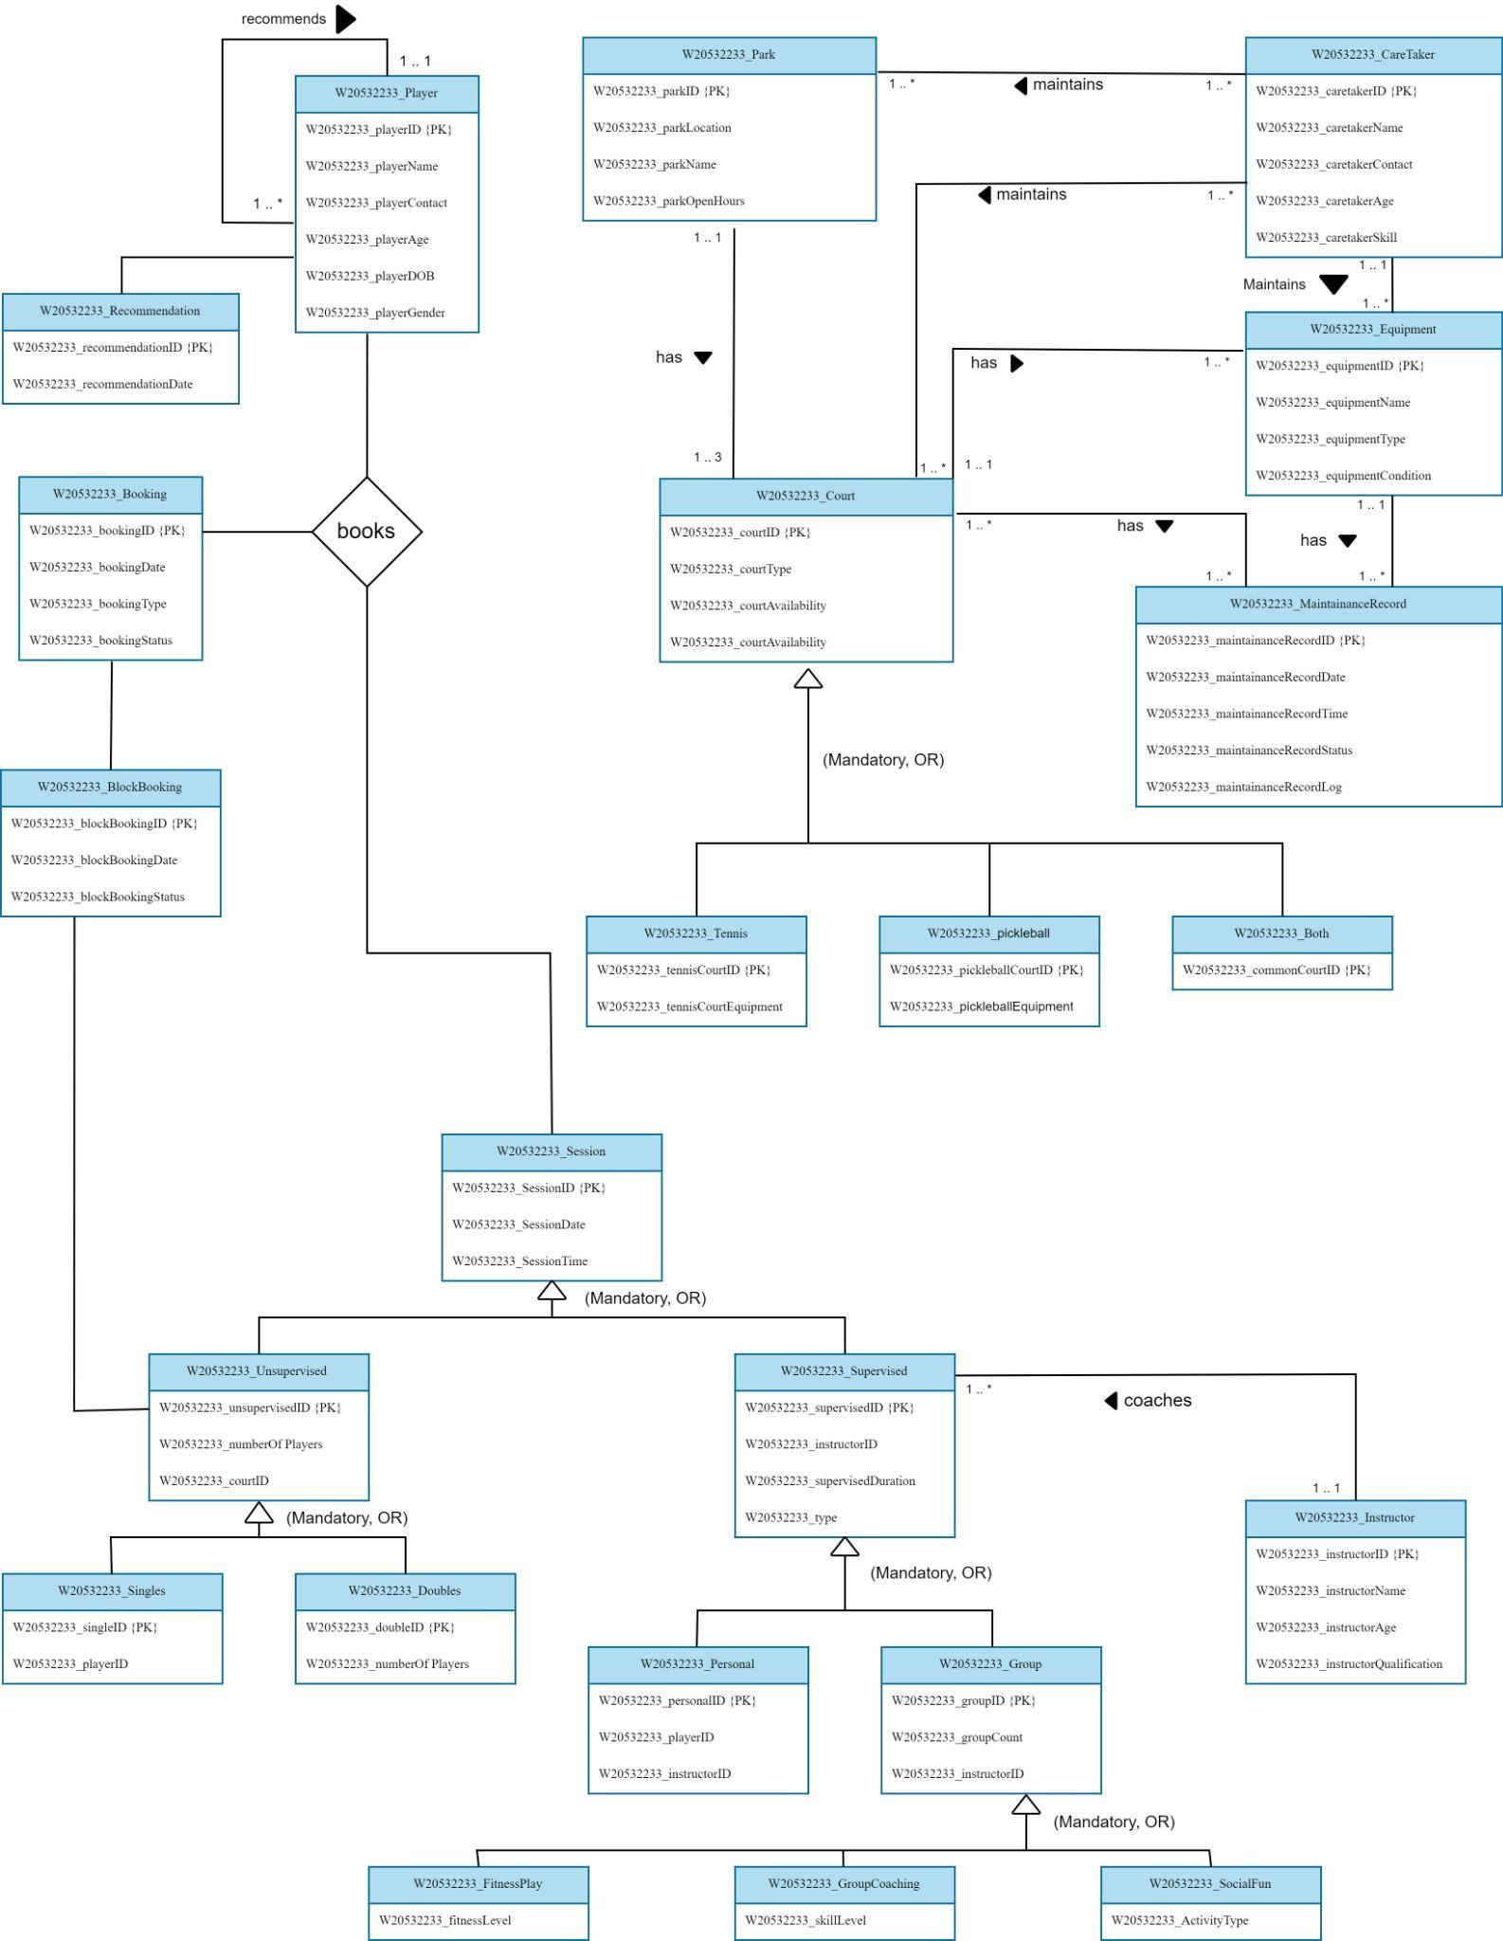
CONCEPTUAL EERD QUALITY & NOTATIONS

BUSINESS QUESTIONS

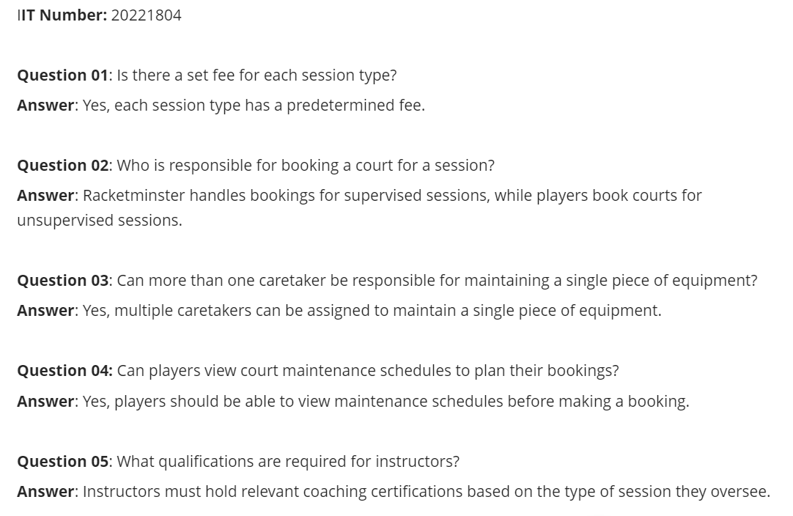

B. LOGICAL ENTITY RELATIONSHIP DIAGRAM (ERD)
